|  |
| --- |
| **UNIT 1: TRANH CÓ NGƯỜI** |

**I. PHÂN TÍCH TRANH CÓ 1 NGƯỜI:**

1. Trong các câu mô tả tranh có 1 người, cần quan sát kĩ động tác của người trong hình. Đây là dạng câu mô tả đặt con người làm trung tâm nên thường sẽ mô tả hành động của người bằng cấu trúc chủ động của thì hiện tại tiếp diễn “is + V-ing”. Đôi khi cũng có câu mô tả những đồ vật xung quanh người đó.

2. Các câu mô tả 1 người thì thường có danh từ hoặc đại từ chỉ người số ít: a/the man; a/the woman; he/she. Các câu có chứa danh từ hay đại từ số nhiều: the men/women; the/some/many people; some/many + danh từ chỉ người số nhiều; they là các phương án sai.

3. Tranh có 1 hoặc nhiều người nói chung chiếm số lượng lớn trong Part 1 TOEIC, nên học viên cố gắng nắm vững từ vựng và các câu mô tả loại tranh này.

4. Ví dụ & phân tích:

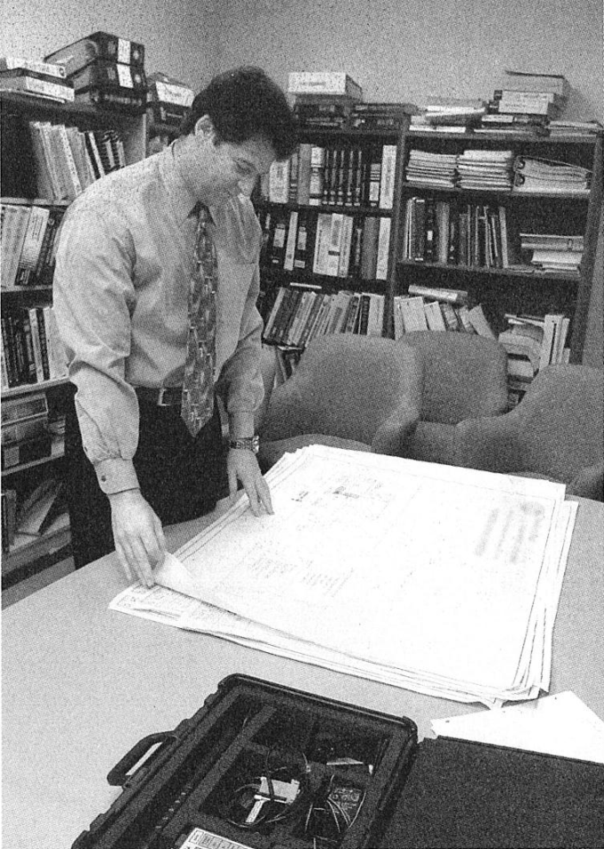

a. Phân tích hành động của người trong hình:

• He is reviewing/examining some documents. [Anh ấy đang xem xét một số tài liệu.]

• He is looking at some documents. [Anh ấy đang nhìn vào một số tài liệu.]

• He is standing by a table. [Anh ấy đang đứng cạnh một cái bàn.]

b. Phân tích những vật xung quanh:

• The chairs are unoccupied. [Những cái ghế không có ai ngồi.]

• Some books have been arranged in the shelves. [Vài cuốn sách đã được xếp trên kệ.]

**II. PHÂN TÍCH TRANH CÓ NHIỀU NGƯỜI:**

1. Trong các câu mô tả tranh có nhiều người cần quan sát kĩ động tác của riêng từng người trong hình, động tác chung của nhiều người và vị trí tương đối của họ với nhau.

2. Các câu mô tả có thể mô tả hành động của 1 trong số những người đó, hoặc cũng có thể mô tả hành động chung của nhiều người; những câu mô tả hành động của người vẫn dùng cấu trúc chủ động của thì hiện tại tiếp diễn “is/are + V-ing”. Ngoài ra ta cũng chú ý đến vị trí tương đối giữa những người trong tranh để nghe đúng giới từ chỉ vị trí, và đôi khi cũng có câu mô tả đồ vật xung quanh.

3. Các câu mô tả hành động chung của nhiều người thì thường có danh từ hoặc đại từ số nhiều: the men/women; some/many people; they; some/many + danh từ chỉ người số nhiều.

4. Các câu mô tả hành động của riêng 1 người trong những người đó thì có danh từ hoặc đại từ số ít: A man/woman; one man/woman; one of the men/women.

5. Tranh có nhiều người cũng chiếm số lượng tương đối trong part 1.

6. Ví dụ & phân tích:

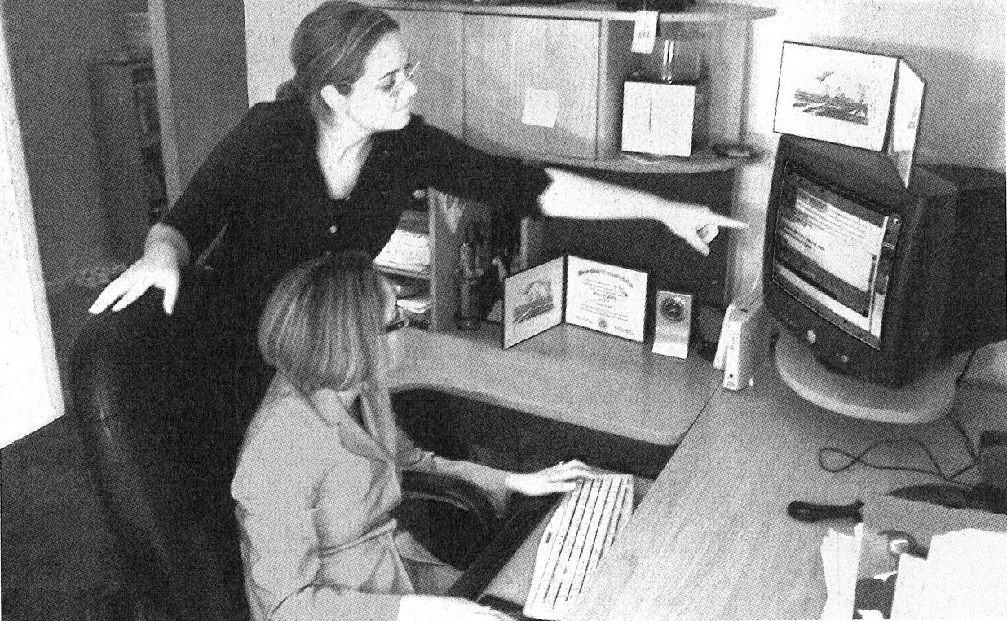

a. Phân tích hành động chung của những người trong hình:

• They are working together. [Họ đang làm việc cùng nhau.]

• They are looking at the computer. [Họ đang nhìn vào máy tính.]

• The women are wearing glasses. [Những người phụ nữ đang đeo kính.]

b. Phân tích hành động của riêng từng người trong hình:

• A woman is pointing at the screen.

[Một người phụ nữ đang chỉ vào màn hình.]

• One of the women is sitting at the desk.

[Một người phụ nữ đang ngồi tại bàn làm việc.]

c. Phân tích những vật xung quanh:

• A computer has been turned on.

[Một cái máy tính đã được mở lên.]

• The door of the room has been left open.

[Cửa ra vào căn phòng đã được để mở.]

**II. NGHE & PHÂN TÍCH TRANH ĐỂ CHỌN CÂU ĐÚNG NHẤT:**

***1. Nghe & tập phát âm***

a. Tranh số 1 **(01.mp3)**

|  |  |
| --- | --- |
|  | (A) She’s closing the door.  (B) She’s lying on the sofa.  (C) She’s holding a piece of paper.  (D) She’s writing a letter. |

b. Tranh số 2 **(02.mp3)**

|  |  |
| --- | --- |
|  | (A) He’s reading a magazine.  (B) He’s putting up a display case.  (C) He’s getting into a vehicle.  (D) He’s looking at a sign. |

c. Tranh số 3 **(03.mp3)**

|  |  |
| --- | --- |
|  | (A) They’re walking on a path.  (B) They’re cutting the grass.  (C) They’re looking at their maps.  (D) They’re sitting in a circle. |

d. Tranh số 4 **(04.mp3)**

|  |  |
| --- | --- |
|  | (A) They’re looking at the screen.  (B) They’re sitting next to each other.  (C) They’re organizing the desk.  (D) They’re decorating the walls. |

e. Tranh số 5 **(05.mp3)**

|  |  |
| --- | --- |
|  | (A) He’s _______ a car.  (B) He’s _______ a wheelbarrow.  (C) He’s _______ air into a tire.  (D) He’s _______ boxes. |

***2. Câu hỏi luyện tập***

**01. (06.mp3)**

|  |  |
| --- | --- |
|  | (A) He’s _______ bookshelves.  (B) He’s _______ his papers in boxes.  (C) He’s _______ from the shelf.  (D) He’s _______ a book in paper. |

**02. (07.mp3)**

|  |  |
| --- | --- |
|  | (A) He’s _______ the snow.  (B) He’s _______ on a sled.  (C) He’s _______ his jacket.  (D) He’s _______ a hat. |

**03. (08.mp3)**

|  |  |
| --- | --- |
|  | (A) She’s _______ some shoe boxes.  (B) She’s _______ a shoe.  (C) She’s _______ a shelf.  (D) She’s _______ a handbag. |

**04. (09.mp3)**

|  |  |
| --- | --- |
|  | (A) He’s _______ a tool belt.  (B) He’s _______ a house.  (C) He’s _______ some wood.  (D) He’s _______ his hat. |

**05. (10.mp3)**

|  |  |
| --- | --- |
|  | (A) He’s _______ a machine.  (B) He’s _______ his sleeves.  (C) He’s _______ an electrical cord.  (D) He’s _______ his jacket. |

**06.** **(11.mp3)**

|  |  |
| --- | --- |
|  | (A) A _______ is being made.  (B) They’re _______ the walls.  (C) One man is _______ the back of a chair.  (D) Cabinets are being _______. |

**07. (12.mp3)**

|  |  |
| --- | --- |
|  | (A) She’s _______ a book.  (B) She’s _______ a machine.  (C) She’s _______ the pages of a newspaper.  (D) She’s _______ some wallpaper. |

**08. (13.mp3)**

|  |  |
| --- | --- |
|  | (A) The men are _______ work vests.  (B) The men are _______ a shelf.  (C) The men are _______ traffic.  (D) The men are _______ outdoors. |

**09. (14.mp3)**

|  |  |
| --- | --- |
|  | (A) He’s _______ a briefcase.  (B) He’s _______ a hat.  (C) He’s _______ a plane.  (D) He’s _______ the ground. |

**10. (15.mp3)**

|  |  |
| --- | --- |
|  | (A) The man is _______ a sheet of paper.  (B) The man is _______ a drawer open.  (C) The man is _______ gifts.  (D) The man is _______ shelves. |

**11. (16.mp3)**

|  |  |
| --- | --- |
|  | (A) They’re _______ in a shop.  (B) They’re _______ some steps.  (C) They’re _______ outdoors.  (D) They’re _______ bricks. |

**12. (17.mp3)**

|  |  |
| --- | --- |
|  | (A) A man is _______ a picture.  (B) A man is _______ for a purchase.  (C) A man is _______ a photograph.  (D) A man is _______ a camera. |

**13. (18.mp3)**

|  |  |
| --- | --- |
|  | (A) The man is _______ his watch.  (B) The bicycle is _______ on the ground.  (C) The man is _______ the shop.  (D) The bicycle is in a _______. |

**14. (19.mp3)**

|  |  |
| --- | --- |
|  | (A) The woman’s hands are _______.  (B) The woman is _______ in the garden.  (C) The woman’s hat is _______.  (D) The woman is _______ by flowers. |

**15. (20.mp3)**

|  |  |
| --- | --- |
|  | (A) He’s _______ his luggage.  (B) He’s _______ his briefcase.  (C) He’s _______ a laptop computer.  (D) He’s _______ two computers. |

**IV. BÀI TẬP VỀ NHÀ:**

**01. (21.mp3)**

|  |  |
| --- | --- |
|  | (A) The woman is _______ a cup of coffee.  (B) The woman is _______ near the machine.  (C) The woman is _______ a document.  (D) The woman is _______ the machine. |

**02. (22.mp3)**

|  |  |
| --- | --- |
|  | (A) She’s _______ her hands.  (B) She’s _______ gloves.  (C) She’s _______ her hair.  (D) She’s _______ on her coat. |

**03. (23.mp3)**

|  |  |
| --- | --- |
|  | (A) They’re _______ cups.  (B) They’re having a _______.  (C) They’re _______ their glasses.  (D) They’re _______ in a conference  room. |

**04. (24.mp3)**

|  |  |
| --- | --- |
|  | (A) A man is _______ a paper.  (B) A woman is _______ notes.  (C) Some people are being _______ to their  seats.  (D) Some people are _______ the window. |

**05. (25.mp3)**

|  |  |
| --- | --- |
|  | (A) They’re _______ notebooks.  (B) They’re _______ for their plates.  (C) They’re _______ next to one  another.  (D) They’re _______ food and drinks. |

**06. (26.mp3)**

|  |  |
| --- | --- |
|  | (A) He’s _______ a bookcase.  (B) He’s _______ some furniture.  (C) He’s _______ a wire.  (D) He’s _______ a hole in a piece of wood. |

**07. (27.mp3):**

|  |  |
| --- | --- |
|  | (A) The man and woman are _______ their  luggage.  (B) The woman is _______ on the board.  (C) The woman is _______ a book to the  man.  (D) The man has a _______ his shoulder. |

**08. (28.mp3)**

|  |  |
| --- | --- |
|  | (A) They’re _______ some photographs.  (B) They’re having a _______.  (C) They’re _______ their watches.  (D) They’re _______ hands. |

**09. (29.mp3)**

|  |  |
| --- | --- |
|  | (A) The woman is _______ a painting.  (B) The woman is _______ in a museum.  (C) The woman is _______ a picture.  (D) The woman and man are _______ some artwork. |

**10. (30.mp3):**

|  |  |
| --- | --- |
|  | (A) They’re _______ the ladder.  (B) One man is _______ a can of paint.  (C) They’re _______ the roof.  (D) One man is _______ a long pole. |

**11. (31.mp3)**

|  |  |
| --- | --- |
|  | (A) The woman is _______ inside the cabinet.  (B) The door to the _______ is open.  (C) The workers are _______ their equipment.  (D) The lab technician is _______ the door. |

**12. (32.mp3):**

|  |  |
| --- | --- |
|  | (A) They’re _______ in a line.  (B) They’re _______ items from their  bags.  (C) They’re _______ the lights.  (D) They’re _______ each other. |

**13. (33.mp3):**

|  |  |
| --- | --- |
|  | (A) They’re _______ in front of an outdoor shop.  (B) They’re _______ the storewindows.  (C) They’re _______ a class.  (D) They’re _______ the sunglasses. |

**14. (34.mp3)**

|  |  |
| --- | --- |
|  | (A) The man is _______ a spray bottle.  (B) The man is _______ the floor.  (C) There are _______ under the counter.  (D) The _______ are open. |

**15. (35.mp3)**

|  |  |
| --- | --- |
|  | (A) She’s _______ in the art gallery.  (B) She’s _______ a large pile of books.  (C) She’s _______ at a painting.  (D) She’s _______ a photograph of some artwork. |

**16. (36.mp3)**

|  |  |
| --- | --- |
|  | (A) Two men are _______ their bicycles through the park.  (B) Some people are _______ on the benches.  (C) A man is _______ the birds by hand.  (D) There’s a _______ beside the path. |

**17. (37.mp3):**

|  |  |
| --- | --- |
|  | (A) People are _______.  (B) People are _______.  (C) People are _______  (D) People are _______. |

**18. (38.mp3):**

|  |  |
| --- | --- |
|  | (A) They’re _______ some  documents.  (B) They’re _______ sheets of paper.  (C) They’re _______ a slide show.  (D) They’re _______ on the wall. |

**19. (39.mp3):**

|  |  |
| --- | --- |
|  | (A) One man is _______.  (B) One man is _______.  (C) One man is _______ from the  wall.  (D) One man is _______ of theroom. |

**20. (40.mp3):**

|  |  |
| --- | --- |
|  | (A) One of the women is _______.  (B) Some women are _______.  (C) One of the women is _______.  (D) Some women are _______. |